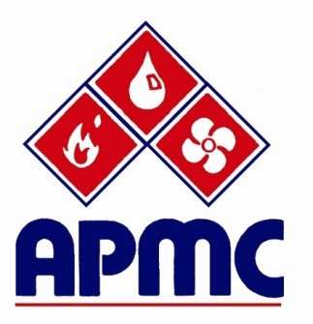

News Leaks

Save the Date
December 2nd – Big Cheese Event

29th Annual APMC Tournament

The 29th Annual APMC Bob Gray Memorial Golf Tournament will be recorded as a success, if for no other reason than the beautiful 80° day, which almost erased the memory of the past two golf tournaments with temperatures that soared will into the triple digits.
One hundred thirty-two golfers joined us at Timber Creek Golf Course for the 29th Annual APMC Golf Tournament.

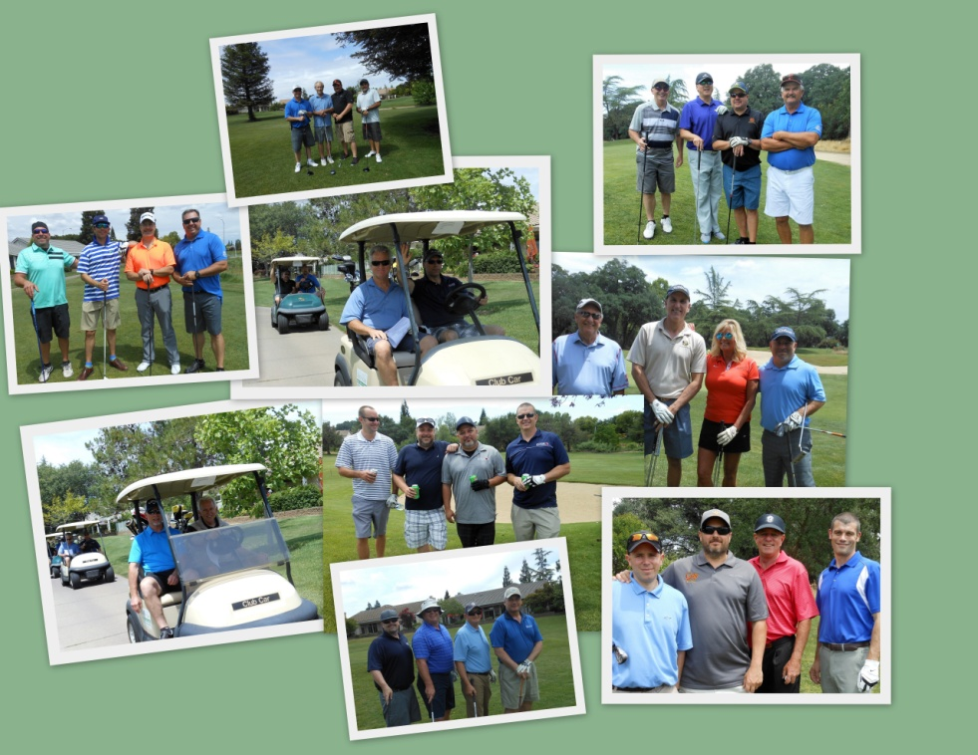

Thanks go out to our many volunteers at registration and on the course. Tanya Brady with Elmco Associates; Melissa Bennett and Jerry Kinch, Lawson Mechanical; Lorretta Laslo, Intech Mechanical; Joan Carnago, Airco Companies; Eric Key, APMC; and Samantha Creasey & Crystal Brooks, Sierra Forever Families - Copper for Kids Program.

Winner of best on-course food goes to Columbia Specialty – Eddie Long and the crew from Columbia did it right! Second runner-up were the wings at the margarita and snack station! Best “Not your Father’s Root Beer” floats on the course and maybe on earth goes to NCCT.

Al Morris with Zurier and the folks from PCI helped keep everyone hydrated with beverage carts regularly making the rounds. On course beverage tubs were stocked by Lawson Mechanical and Kraw Law Group.

Now to the winners.
- Bill Taylor from California State Pipe Trades won the putting contest sponsored by Sacramento Windustrial.
- Jon Pierce with ACCO won the “Most Accurate Drive”.
- Third Place went to the Victaulic foursome – Jonathon Shipley, John Brusa, Erick Tickler, and Ryan Ainsworth with a score of 61.
- Second Place went to the California State Pipe Trades foursome – Greg Partch, Bill Taylor, Greig Hope, and Che Timmons with a score of 59.
- After the scorecard playoff, First Place went to the PCI foursome – Lance Bolden, Mike Sisney, Patrick Sharkey, and David Texdahl with a score of 59.

Thanks to Air Systems and Community 1st Bank for sponsoring the wine for dinner and to our contributing sponsors Kaiser Permanente, Heieck Supply/Rheem, Victaulic, and Elmco + Associates.
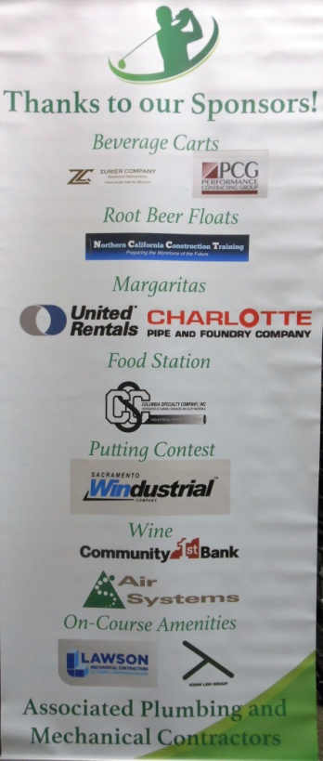

OSHA Heat Stress Information

“OSHA has kicked off its summer campaign to inform employers and employees about the dangers of working in the heat. The campaign will continue its annual outreach to highlight how heat-related worker fatalities are entirely preventable. In 2014 alone, 2,630 workers suffered from heat illness and 18 died from heat stroke and related causes on the job.”
This is the top story in OSHA’s news letter sent out today. We need to make sure that we include something in our High Heat section of our Daily AM Huddles, about what we expect to do in the event of a worker experiencing Heat Illness. Make sure that you are not glossing over this area. OSHA is out and looking for persons working outdoors, and asking them to explain the Heat Illness training they have received. Make sure you are talking each and every day to your crews about this important subject.
If you are working indoors, in a conditioned space, write it down. Make sure to document, document, document!
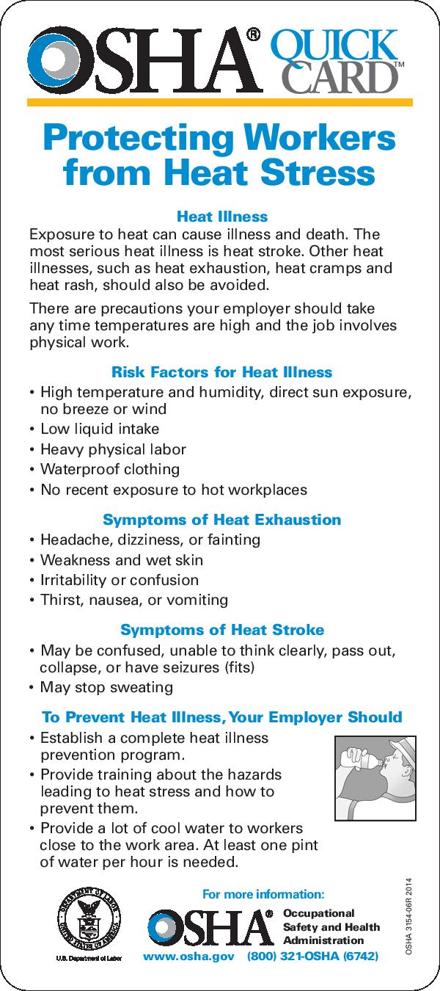
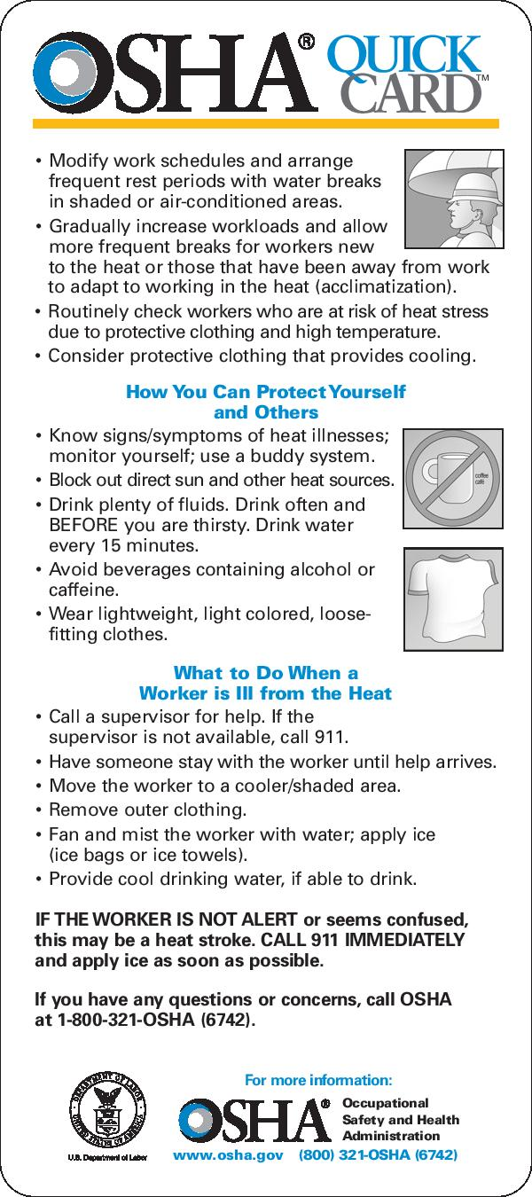

APMC Membership Meeting

APMC held a member event at Gold River Distillery in Rancho Cordova Thursday night. Attendees were treated to an insider’s view of how small batch craft distilled spirits are made, by our host, Greg Baughman, who opened the distillery and tasting room nearly two years ago.

During the days of Prohibition, Sacramento was one of the easiest places to find a drink in California. Riverboats were used to ship alcohol throughout the region. Those brave enough to transport moonshine piloted their boats from the wheelhouse assuring a thirsty population something to lift their “spirits”.

Greg provided “tastes” of his Wheel House gin and vodka during his presentation, each an interesting twist on what is taste trending in the marketplace. Greg plans to add both absinthe and whiskey to his product line before the end of the year. Currently Wheel House is available at Total Wine, BevMo and Nugget Markets.

