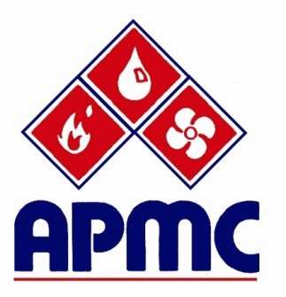

News Leaks

**Save the Date**

***December 4th – Big Cheese Event***

**28th Annual APMC Tournament**

28th Annual APMC Golf Tournament Successful Despite Soaring Temperatures

One hundred fourteen golfers braved this year’s hottest day yet at Timber Creek Golf Course for the 28th Annual APMC Golf Tournament.

Thanks go out to our many volunteers at registration and on the course. Tanya Brady with Elmco Associates; Mark Freed with H.C. Fletcher; Jerry Kinch, Airco Mechanical;

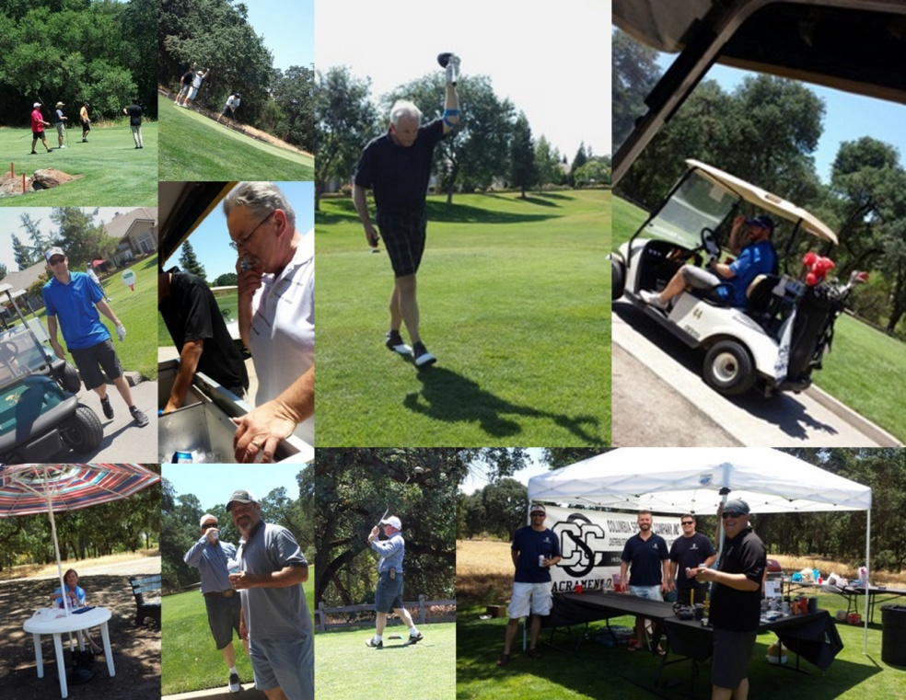Lorretta Laslo, Intech Mechanical; Phil Ribbs, CISPI (Cast Iron Soil Pipe Institute); Freida &

Dick Cleverly, Harry Moos, Ed Bray, Michaela Donnenwirth, Eric Key, Fia Hoskinson; and Samantha Creasey & Crystal Brooks, Sierra Forever Families - Copper for Kids Program.

Winner of best on-course food goes to **Columbia Specialty** – Eddie Long and the crew from Columbia did it right! Second runner-up were the wings at **L & H Airco’s** snack station! Best ice cream on the course goes to **NCCT** and Gunther’s Ice Cream and there was a tie for most refreshing beverage winner – Ray Butcher with **Charlotte Pipe** dispensed some mean margaritas and Bev Hoeft with **Bank of Sacramento** and Justin Oliveraz with **Cal Steam** not only had high-end beverages but cigars to go with. When you see these folks next, let them know how much you enjoyed their provisions.

Al Morris with **Zurier** and the folks from **MIFAB/Kliman** helped keep heat stroke at bay with beverage carts regularly making the rounds. On course beverage tubs were stocked by **Verus** and **California State Pipe Trades**.



Now to the winners.

* Mark Schroeder from Synhorst Sales won the putting contest sponsored by **Sacramento Windustrial**.
* Chris McDaniel with the Pipe Trades Trust Office won the “Most Accurate Drive”.
* Third Place went to the Peter Bolton, John Brusa, Eric Tickler and Josh Twist foursome with a score of 62.
* Second Place went to the Tyler Countryman, Mike Harper, and Carey Tinker golf trio with a score of 61.
* First Place went to the Mike Baker, Mark Reidmiller, Jon Shipley and Bob Weisenberg with a score of 60.

Thanks to **Air Systems** and **Intech Mechanical** for sponsoring the wine for dinner and to our contributing sponsors **Lawson Mechanical**, **Heieck Supply/Rheem, Victaulic, Sierra Forever Families** and **IAPMO.**

And, finally thanks to Chuck Zimmerman with **Milwaukee Tools**; Rob Yoast with **RepCor**; Bev Hoeft with **Bank of Sacramento**; and Christie Shorrock with **Sierra Forever Families/Copper for Kids** for their raffle prize donations.

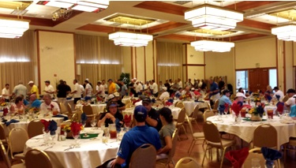

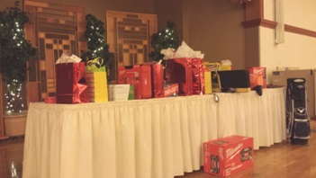

**Golf Lost and Found**

Two personal items were found at the Timber Creek Golf Course following APMC’s tournament on June 8th. First is a Mizuno putter cover and second is a pair of prescription sunglasses in a SunGear case. Call or email Claire to arrange to have your lost items returned – 916/475-1226 or [claired@sacvalleyassoc.net](mailto:claired@sacvalleyassoc.net).

**L&H Airco Announces Key Leadership Promotions**

Dick Racette, Vice President, of L & H Airco announced promotions for three key individuals who have spent a combined fifty years helping lead and grow L & H Airco.

Eric Crise has been promoted to General Manager, assuming responsibility for all sales, operations and accounting activities. He will be responsible for both employee and customer satisfaction while continuing to develop software tools needed to increase efficiencies and capabilities.

Jake Garcia has been promoted to Vice President of Sales. He will lead and manage all sales activities in the three California offices. Jake is a registered PE who started with L & H fourteen years ago.

John Harris has been promoted to Vice President of Business Development. John will expand his sales activities by developing vertical markets, evaluating product offerings and expanding customer relationships. Recently John marked his twenty year anniversary with L & H Airco.



